Please mail this form and a check, made out to LANA, so that they arrive by
April 12, 2019
to:
Joy Pedroni
LANA Office
3966 Estate Dr.
Vacaville, CA 95688
Kids & Camelids  April 27, 2019  Show Fee Summary | 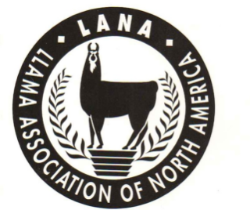

Youth Handler’s Name:

Youth Handler’s Address: ___________________________

Parent’s email: Parent’s phone number:

Youth Handler’s Parents’ Names: _________________________________________________________________________
Youth  ALSA # | Handler’s  Birthdate | As of Jan. 1, 2019  Sub Junior (<8)  Junior (8-11)  Intermediate (12-14)  Senior (15-18) | Youth Handler is in a (Circle one) | Please indicate if the youth handler plans to bring a non-ALSA “friend” to the show to try out an obstacle course.  □ Yes □ No
Sub junior Junior
Intermediate Senior

Llama or Alpaca Name | Animal ILR # |  | Youth Registration Fees:  LANA youth members: $25  Nonmembers: $40 |  | Reg fee | ALSA fee | Total
 |  |  |  |  |  | $5
All Entrants must read and sign: It is understood and agreed that LANA; ALSA; and the owners of Macedo’s Mini Acre and their officials, employees and agents shall not be responsible for any loss, damage, or injury to any person, property or animal which is caused directly or indirectly for any reason. The undersigned also agrees to hold harmless LANA, ALSA and the owners of Macedo’s Mini Acre for any expense or liabilities, including attorney’s fees.
Exhibitor’s Parent’s Signature: Date:

