Fiber  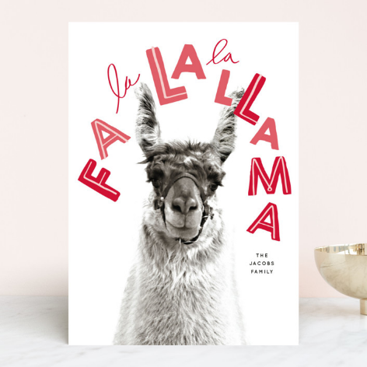  TO DO LIST:  ALL: consider volunteering to help set up the Hobo Show obstacles on Friday, Jan. 27, between noon and 4 PM  Sue: send out the approved bylaws to members and request proxy votes for those who cannot attend  Sue: create a draft Annual Meeting agenda for the Jan. 19 Board meeting  ALL: submit membership forms for 2023, if applicable  Sue: resend LANA membership forms to eBlast list after the New Year  ALL: vote for the Director position for which we have a candidate running, if applicable  Sue: get articles/photos to Kathy for the winter newsletter  Joy: continue to make plans with Sly Park for 2nd weekend in June.  Stephanie: convert the Kids & Camelids flyer to form for website posting & sent to Joy  ALL: mark Sept. 16 for American River clean up  ALL: check out Rondi’s you tube channel: @RondiSmith8140 | LANA Board of Directors Meeting  December 15, 2022  Minutes
Present: Lee Beringsmith, Margaret Drew, Joy Pedroni, Stephanie Pedroni, Susan Rich. and Rondi Smith
Absent: Emily Muirhead, Kathy Nichols and Cathy Spalding
 | Call to order and review of the agenda: Secretary Susan Rich called the meeting to order at 6:34 PM. It was noted that President Kathy was absent, and Vice President Stephanie requested that the Secretary facilitate the meeting. The agenda was reviewed, and no changes were requested.
Past meeting minutes
Approval of November 16, 2022 minutes: Joy moved that the minutes be approved as written, and Margaret seconded. The motion was unanimously approved.
Review of “To Do List”: Susan reviewed the To Do List from the November meeting.
Treasurer’s Report
Joy reviewed the notes below that she provided before the meeting. There were no changes to the LANA Lama Lifeline budget. General Fund activity was reviewed as noted below. Joy added that Liability Insurance is to be paid, and it will cost approximately $600.
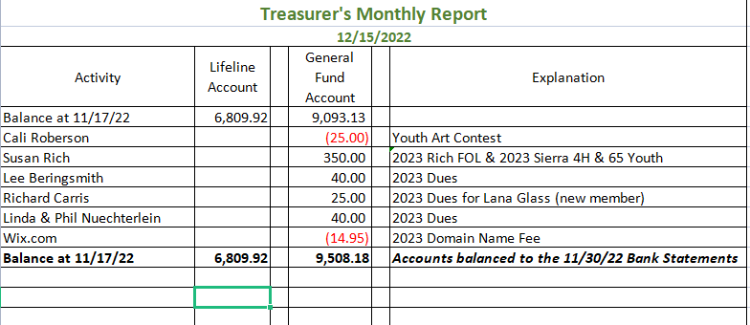
Secretary’s Report
- Correspondence: US Mailings included a note of concern to the Beringsmiths, hard copy membership form and Hobo Show paperwork to the Kanes, a Director’s ballot and membership form to Crystal Myers, and thank you’s for new memberships to Jono Spelbring and Lana Glass.
- LANA email’s inbox: Sue shared the Happy Thanksgiving message from the Rocky Mountain Llama and Alpaca Association, and she shared the email Director votes from the following LANA members: Trish Brandt-Robuck, Eileen Ditsler, Kathy Nichols, Orange Blossom 4H Club, Elaine Partlow, Joy Pedroni, Susan Rich, Cathy Spalding, Karen Wagner, and Terri Watts.
- By law discussion (last one!) and approval: Sue reviewed a few suggested edits to the draft version of the bylaws. Joy moved that the draft bylaws, inclusive of the suggested edits be approved by the Board of Directors, and Stephanie seconded. There was relatively little discussion, and the motion was approved unanimously.
Hobo Show
- Updates & discussion: Joy received a formal contract from the Merced Fairgrounds, and it has been signed by both parties. The facilities man will review his records from last year in regard to number of tables and chairs, etc. Course set up starts at 12 Noon. Therefore, volunteers are needed on Friday afternoon. The barn is rented for all day Friday, so attendees can arrive at any time on Friday. Kathy and Joy and Steph will work on ribbons and awards. There is no information about dinner yet. Should we repeat last year’s menu and use the same caterer? Sue and Lee thought the food was good. Joy and Kathy can work out the food again. Sue indicated that she had purchased serving utensils, and we should still have them. We need to remember to bring them. Presumption: Kathy will load her vehicle with all the obstacles and bring them down on Friday.
- Auctions:
  - Silent auction: LANA & Lifeline tables: Sue reviewed the auction item slips that were mailed out along with the Hobo packet. They include the options for a minimum bid and buy it now. It was noted that Lisa will pick up the Circuiteer blower for auction. She asked that everyone donating to the silent auction come with their slips already filled out.
  - Dessert: Sue supplied slips for Board members who bring desserts for the auction to fill out. These really help to keep track of donors and amounts. All proceeds will go to Lifeline.
- Annual Meeting & Dinner: The Annual Meeting will take place on Saturday. The Board approved bylaws need to be ratified during the meeting. Because many members may not be able to attend the meeting, the Board decided that members could provide a proxy for the bylaws. Sue will send an email to all members to gain their vote. We will be able to finalize an agenda for the meeting at the January Board meeting.
  - LANA Awards: To date, there has been no activity in this area.
2023 LANA Membership Drive
- Numbers to date: Currently, we have: one Friends of LANA membership, one Youth Group membership, one returning membership, and two new members. Board members were reminded to get their memberships in. Sue was asked to resend membership forms right after the first of the year to avoid the holiday chaos.
- Thank you’s w/ stickers: Sue indicated she had purchased stickers and is including about 10-12 with each thank you note. She still has plenty of LANA notecards for this year.
LANA Board Business
- LANA Elections: Sue noted that a quorum of 16 votes was needed for the election of the one seat for which we have a candidate running. She will resend reminders as needed for collecting votes. Board members were reminded to vote.
- Sue reminded the Board that we have a seat for which we have not candidate, and that the bylaws allow the Board to appoint a Director in such instances. Sue moved to appoint Lee Beringsmith to the uncontested seat, and Stephanie seconded the motion. Some discussion ensued. Lee mentioned that he has been in the llama community for 18 years thanks to Margaret, and that he would like to continue to serve on the Board. The motion passed unanimously.
How can we broaden LANA to North America?
Expanding Social Media outreach: Updates
- Dec. 9: National Llama Day – Sue apologized for not putting anything out on the 9th via an eBlast. Joy and Stephanie reached out for a Library Day and didn’t get a response until the very last minute when it was too late to respond. Stephanie posted a week ahead of time and on the day on Lana’s Facebook with fun facts, etc. Lee put something out on his Facebook page as well. We will work to expand our efforts for next year.
- Rocky Mountain’s emailed holiday messages – should we? LANA can put out holiday-related messages as per the Rocky Mountain Association. Stephanie can help blast out on our Facebook. Emily is an editor, along with Lee and Stephanie for posting, so Emily can include these messages on Instagram and Tik Tok.
Newsletter: Sue shared that for the winter edition, she and some of the 4H kids will provide articles and photos about their “field trip” to Greg Harford’s ranch to learn about ccara llamas.
Llamping Plans:
California Plans for 2023: date? Joy has not been able to confirm dates. She will continue to nail down the dates and the price. We are shooting for the second weekend in June.
Kids & Camelids: April 22, 2023
Sue shared that she had prepared a Flyer and selectively emailed it to past youth participants and their parents. This show will not be ALSA sanctioned so that Margaret can judge again. Joy requested a version of the flyer that can be posted on the website. Stephanie will convert it to jpg for posting.
Continued Discussion of Other Possible Activities/Parking Lot
- Fundraising ideas for LAMA Lifeline: Tabled
- Other possible events: Demo for skirting a fleece? Tabled
- Community Service Project: The American River Clean-up is scheduled for Sept. 16th. The designated area is far away from the homeless encampments, closer to the Carmichael area. Q: Any information about what to bring? A: In the past, we were given bags. Bring gloves. Sticks w/ grabber devices at the end. Some people will line their llama packs with bags.
Request for agenda items for next meeting:
- Hobo Show
- Agenda for the Annual Meeting
- Membership Drive
- Plans for felting clinic (Margaret has her barn for inclement weather)
- Discussion about reaching out to membership to ask about what low-cost event they might like
- Brainstorm a calendar of events to avoid camelid conflicts & tentatively assign duties
- Think about/discus how to serve the whole North America: videos? Forum for Q and A for clarification about content of videos?
- Establishing a you tube channel? (Note: Rondi has done this: @RondiSmith8140)
Date for next conference call meeting:
Next meeting: Jan.19, 2022, 6:30 PM
Future meetings: Same position: 3rd Thursday of the month?
Jan. 19, Feb. 16, March 16, April 20 & May 18 (Sue has conflicts for both), June 15, July 20, Aug. 17, Sept. 21, Oct.
19, Nov. 16, Dec. 21. Note: the Board will decide on new dates for the April and May meetings.
Adjournment: Margaret moved to adjourn, and Joy seconded the motion. The meeting was closed at 7:31 PM.

