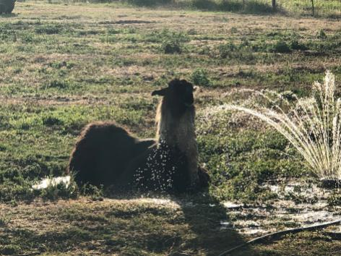 | LANA Board of Directors Meeting  July 11, 2019  Minutes
Present: Jana Kane, Michelle Kutzler, Kathy Nichols, and Susan Rich
Absent: Joy Pedroni, Dolly Peters, and Cathy Spalding.
TO DO LIST:  Michelle: check with those previously emailed regarding LANA membership.  Sue: contact possible LANA member regarding re-upping  Joy: eBlast the newsletters from Kathy: the Kids & Camelids edition and the spring edition  Joy: provide Sue and Kathy with the eBlast group email  Kathy: check with Jerry Kimbro about llama rescues and if the Southwest Rescue had requested Lifeline funds  Kathy: check with Maureen re a date for the felting craft projects and share the date  Jana: check in with Kayla Rogers about a carting clinic and report out | Review of the agenda  Revisions: change of order, request to table items, additions to the agenda, etc.  President Michelle Kutzler called the meeting to order at 7:11 PM.  No requests were made to revise the agenda.
Past meeting minutes
- Approval of June 13, 2019 minutes: Kathy moved to approve the June minutes as written. Jana seconded the motion. There was no discussion, and the motion carried unanimously.
Treasurer’s Report
Financial updates/reports: In Joy’s absence, this item was tabled.
Secretary’s Report
- Update on communications: Sue indicated that she had not sent any letters on behalf of LANA.
 | LANA Membership Drive, con’t.: We reviewed the membership list that Sue provided and culled out those who were no longer involved in the llama community. Michelle indicated she would recheck with Trish Brandt Robuck, the Moglers, and Deb Yeagle. Sue indicated she would check with Marlys Green.
 | Newsletter: Kathy indicated that in old newsletters, a newcomer to LANA was celebrated in the newsletter, and Kathy wants to resurrect that practice. The Kids and Camelids newsletter was posted on Facebook, but it was not ever eBlasted. Sue has not yet seen it. Kathy is hoping to get an article covering the llama rescues. Joy and Ron were able to corral two animals that had been loose since the Paradise fires. Kathy is starting on the early summer newsletter. Sue suggested that Joy share the eBlast group email with Kathy and Sue so that they could send out things and take some of the burden off of Joy. The Southwest rescue is going on. They are trying to get animals placed and there is a Go-Fund-Me venture underway. We wondered if there was any request for LifeLine funding. Kathy will ask Jerry Kimbro about that.
 | Sly Park Alternative Trails – any updates? There is no report on this yet. Neither Kathy nor Joy has had a chance to go up and investigate possible new trails.
 | Plans for Summer Clinics: Kathy will talk to Maureen during State Fair to establish a possible date for wool-craft projects: dryer balls, etc. These might make good Christmas presents. Kathy will send out a date after her discussion with Maureen. Jana has yet to talk to Kayla Rogers about a carting clinic. She plans to make the connection at State Fair as well.
Cal-ILA/LANA Collaboration, con’t.: Michelle has not heard anything from Maureen. The Cal-ILA Board is planning to have a meeting on the last day of State Fair. There should be news coming from that meeting.
Shed Update: date for cement pouring? Tabled in Joy’s absence.
Unfinished/Pending Business:
Holding for a later discussion:
- Future fall/winter events discussion
- Party Show
- Evacuation Webinar
- Sly Park plans
Request for agenda items for next meeting
- Cal-ILA Collaboration
- Summer Clinic Updates
- Standing agenda items
- Shed Update
- Membership update
- Updates on llama rescues
Date for next conference call meeting:
Next Board Meeting: August 8
Calendar for the rest of the year: September 12, October 10, November
14 (Sue is absent), and December 12
Adjournment: Kathy moved to adjourn the meeting, and Jana seconded. The motion passed, and President Michelle Kutzler adjourned the meeting at 7:52 PM.

